NAME: G. Yashmita REG NO: 192511032

(Git/Github)

EXPERIMENT 26:
Clone an existing GitHub repository to your local machine and make
a small change in one of the files.
Tasks:
- Choose an existing public GitHub repository (e.g., your own or a sample repository).
- Clone the repository to your local machine using git clone & lt;repository_url&gt;.
- Navigate into the cloned repository directory and open one of the files.
- Make a small edit, such as modifying a line of text or fixing a typo.
- Save your changes.

Aim
To clone an existing GitHub repository to the local machine and make a small modification to one of its files.

Software Requirements
- GitHub Account
- Git
- Visual Studio Code
- Internet Connection
Procedure

Step 1:

Create a Repository (if you don't already have one)
If you already have a repository (for example, PersonalProject), you can use that.
Otherwise:
- Open GitHub.
- Click + → New repository.
- Name it PersonalProject.
- Select Public.
- Check Add a README.md.
- Click Create repository.

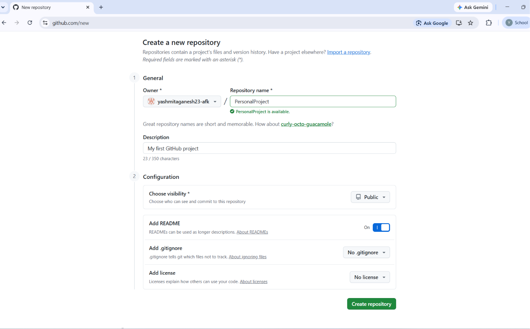
Figure 1: Creation of GitHub Repository

Step 2:

Copy the Repository URL
- Open the repository.
- Click the Code button.
- Copy the HTTPS URL.
Example:
https://github.com/yourusername/PersonalProject.git

Step 3:

Open VS Code
Open VS Code.
Open Terminal → New Terminal.

Step 4:

Go to Documents
Type:
cd Documents
Press Enter.

Step 5:

Clone the Repository
Type:
git clone https://github.com/yourusername/PersonalProject.git
Press Enter.
You should see:
Cloning into 'PersonalProject'...
Receiving objects...
Resolving deltas...

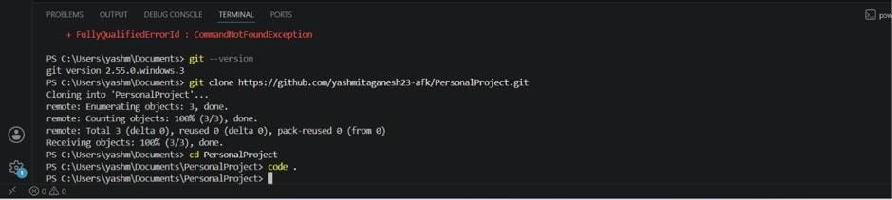
Figure 2: Cloning the Repository
Step 6:

Open the Project Folder
Type:
cd PersonalProject
Then:
code .
This opens the project in VS Code.

Step 7:

Open README.md
Click README.md.
It may look like:
# PersonalProject

Step 8:

Make a Small Change
Add one or two lines below it.
Example:
# PersonalProject

This project is created for the Software Engineering laboratory.

It demonstrates Git repository cloning and file editing.
Press Ctrl + S.
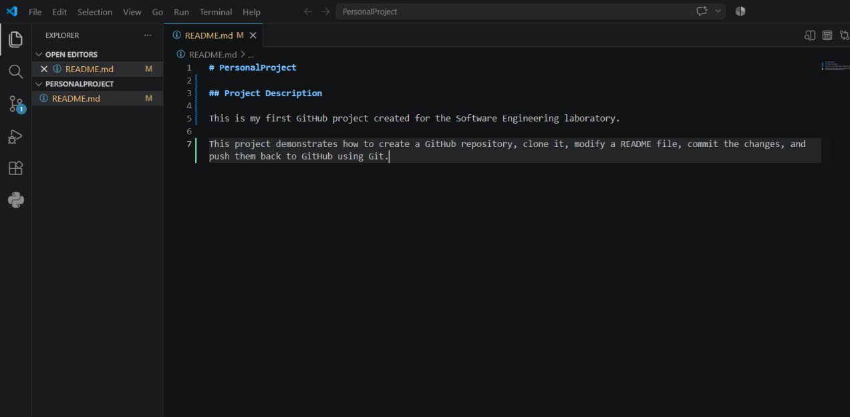
Figure 3: Modified README.md File

Step 9:

Verify the Change
In the terminal, type:
git status
It should display:
modified: README.md
This confirms the file has been modified.
Figure 4: Git Status Showing Modified File

Result
Successfully cloned the GitHub repository to the local machine and modified the README.md file.

